STUDENT DETAILS
NAME : ABDULMALIK HAMED
ADM NO. : BSCCS/2024/33590

COURSE/CLASS : COMPUTER SCIENCE JAN 24

Unit Name: Advanced Web Design and Development

Lecturer Name : MICHAEL NYORO

Semester/Academic Year : YEAR 4 SEM 2

Project Details
- Project Title : ShopMart
- Selected Technologies;
  - PHP + MySQL
  - MEVN Stack
  - Laravel
  - React + Firebase

GitHub Link
https://github.com/saidabdulmalik735-source

Table of Contents
Project Details 1
GitHub Link 1
Week 1: Local Environment Setup 3
Title : Installation and Testing of Local Development Environment 3
Required Evidence 3
Fig 1: Installation of XAMPP 3
Fig 2: Apache and MySQL Running 4
Fig 3: Localhost Test Page 4
Fig 4: Database Connection Test 4
I learnt XAMPP doesn’t easily recognise spacing in naming folders or files. The technologies used was html and sql. 5
Week 2: Wireframes and GUI Design 5
Title : User Interface Planning and System Design 5
Required Evidence 5
Fig 1: Hand-drawn Wireframe 5
Fig 2: Dashboard Layout Design 6
Fig 3: Mobile View Mockup 7
Fig 4: Color Theme and Navigation Structure 7
Fig 5: GUI Prototype in Figma 8
Student Reflection 8
The design was selected due its simplicity and easy to use navigations. User experience was considered through easy naviagtion buttons and quick action buttons that guide the user. 8
Navigation flow was planned based on user experience and quick product selection and check out. Intended system users will be prospective customers 8
Week 3: JavaScript and PHP Basics 8
Title : Frontend Interaction and Backend Foundations 8
Required Evidence 8
Fig 1: JavaScript Form Validation 8
Fig 2: Password Strength Checker 9
Fig 3: PHP Syntax Practice 10
Fig 4: Database Connection Script 11
Fig 5: Dynamic User Input Handling 11
Student Reflection 12
Week 4: Server-Side Components. 12
Fig 1. Login form 13
Fig 2. Admin dashboard 13
Fig 3. Succesful logout and redirect to login page 14
Fig 4. Add product protected 15
Week 5:Database Components & CRUD 16
Fig 1. phpMyAdmin — week5db tables 16
Fig 2. Admin View. Full CRUD table with Edit/Delete buttons, admin logged in 16
Fig 3. Access Denied - Logged in as john_doe 17
Fig 4. Editing a product and succesful update 18
Fig 5. Delete product process 19
Fig 6. SQL Queries in phpMyAdmin 20
Fig 7. Session Info on Dashboard 20

Week 1: Local Environment Setup

Title : Installation and Testing of Local Development Environment

Required Evidence

Fig 1: Installation of XAMPP
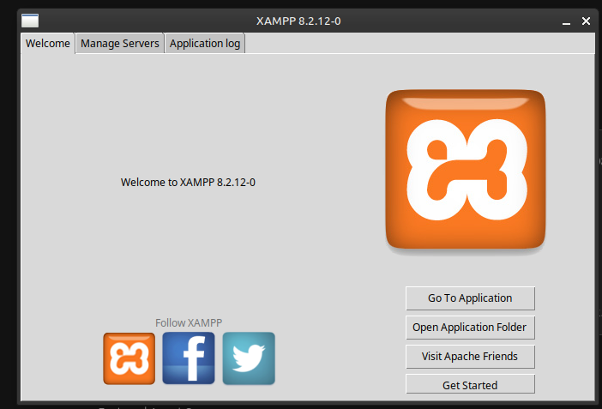

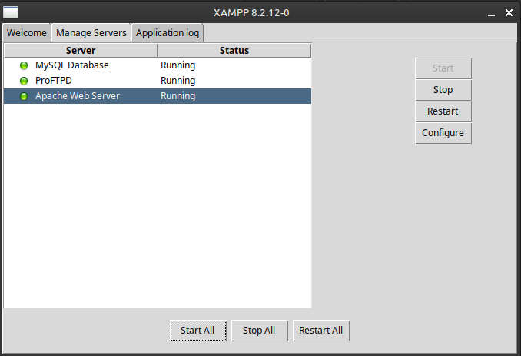
Fig 2: Apache and MySQL Running

Fig 3: Localhost Test Page
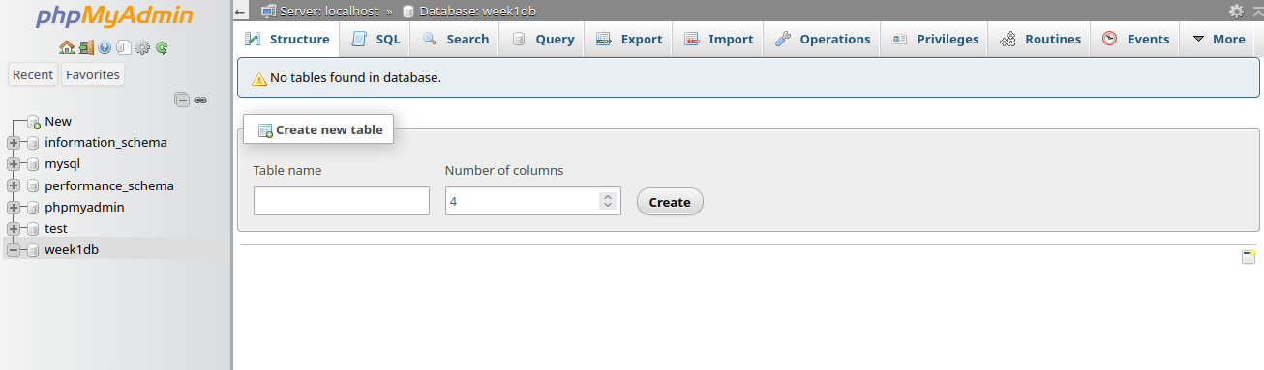

Fig 4: Database Connection Test

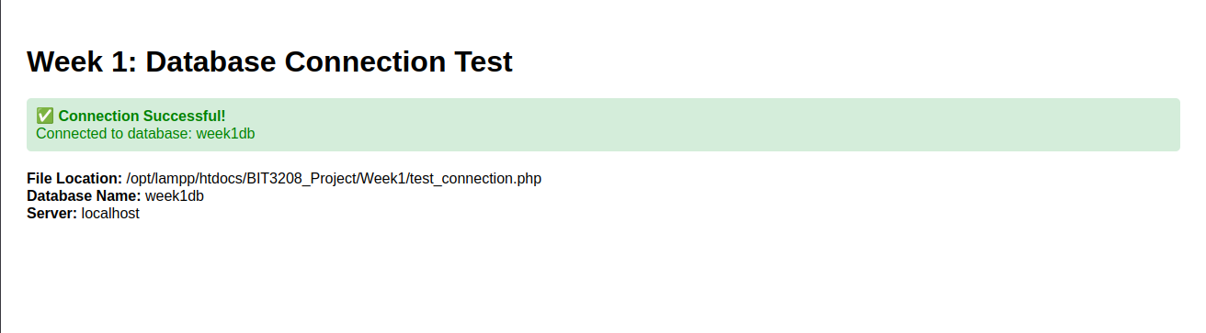

I learnt XAMPP doesn’t easily recognise spacing in naming folders or files. The technologies used was html and sql.

Week 2: Wireframes and GUI Design

Title : User Interface Planning and System Design

Required Evidence

Fig 1: Hand-drawn Wireframe
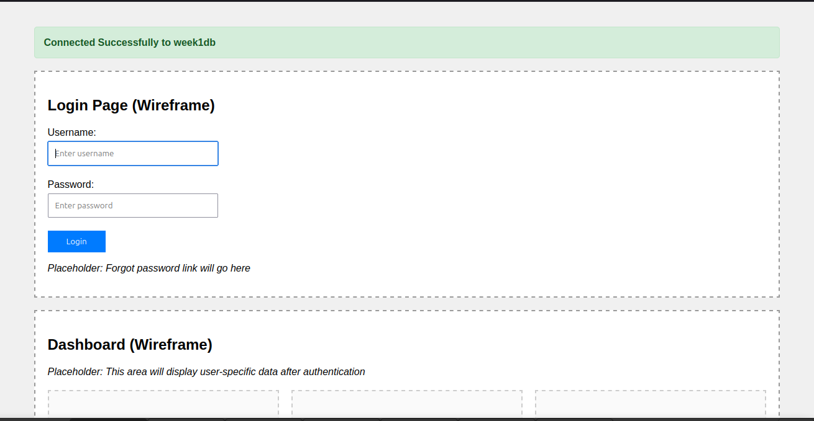

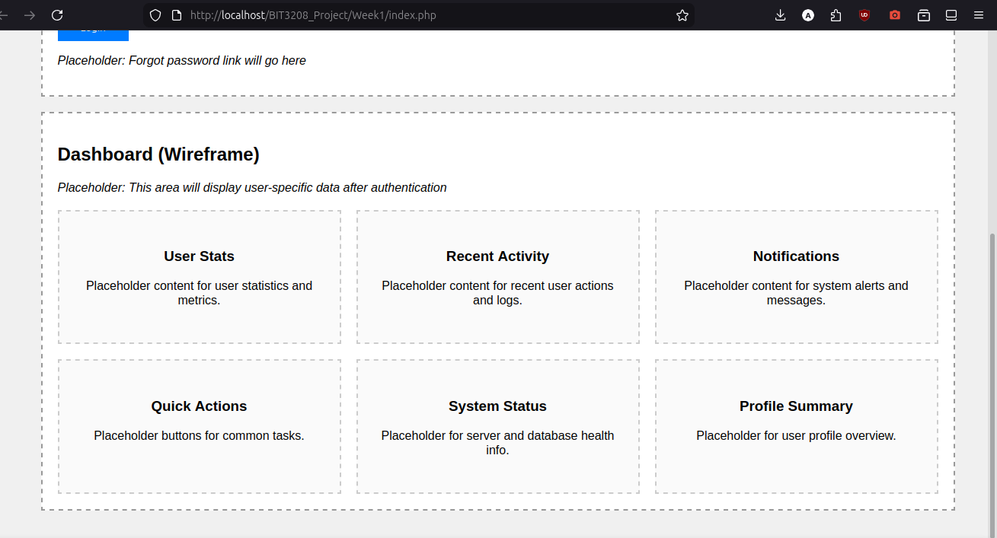
Fig 2: Dashboard Layout Design
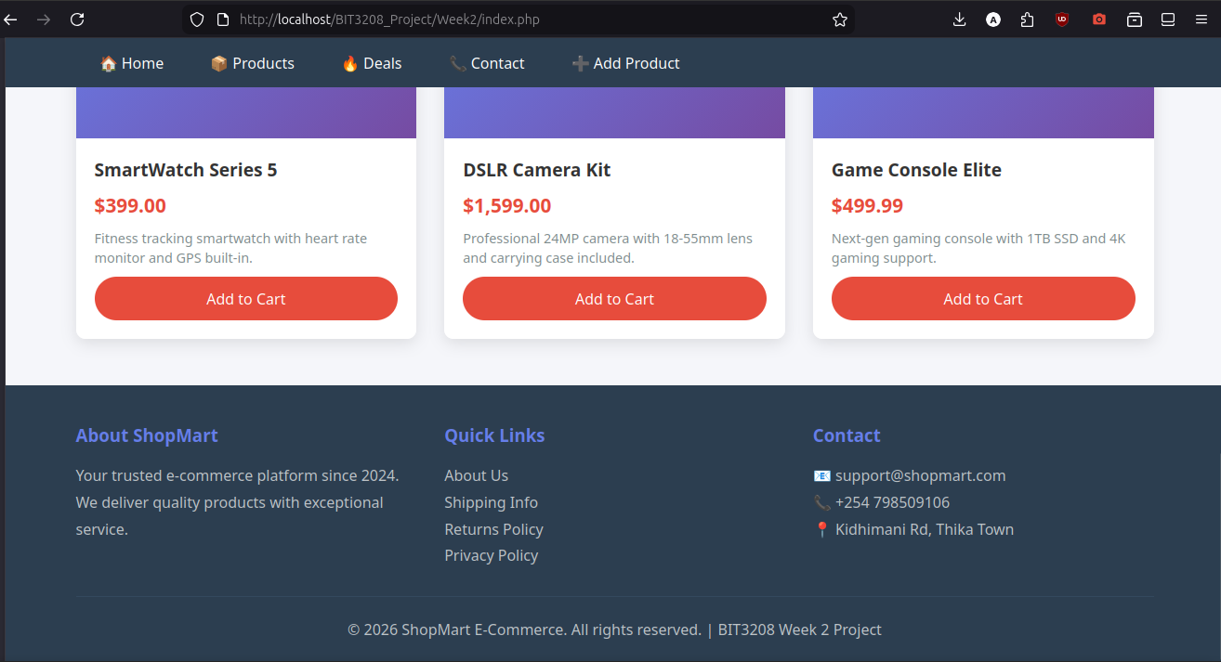
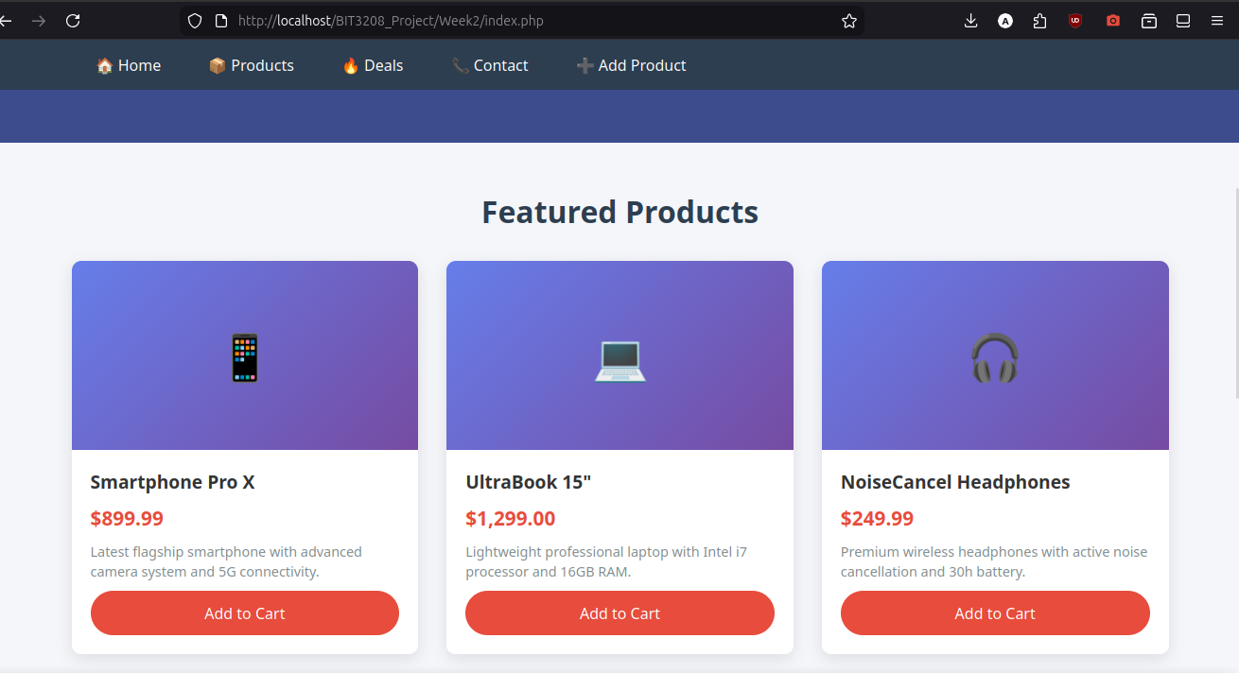

Fig 3: Mobile View Mockup
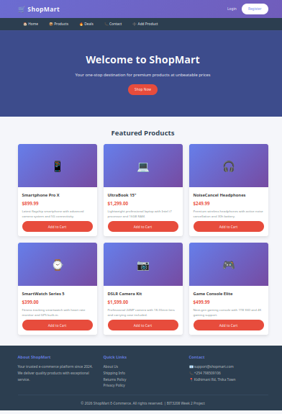

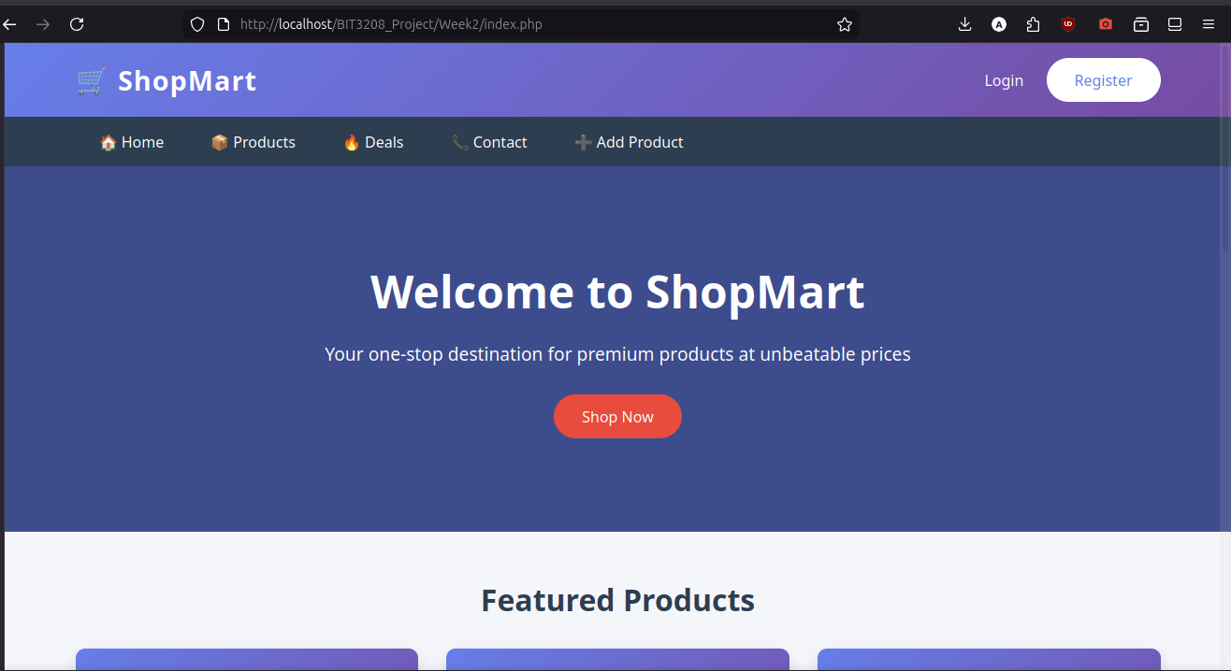
Fig 4: Color Theme and Navigation Structure

Fig 5: GUI Prototype in Figma

Student Reflection

The design was selected due its simplicity and easy to use navigations. User experience was considered through easy naviagtion buttons and quick action buttons that guide the user.

Navigation flow was planned based on user experience and quick product selection and check out. Intended system users will be prospective customers

Week 3: JavaScript and PHP Basics

Title : Frontend Interaction and Backend Foundations

Required Evidence

Fig 1: JavaScript Form Validation
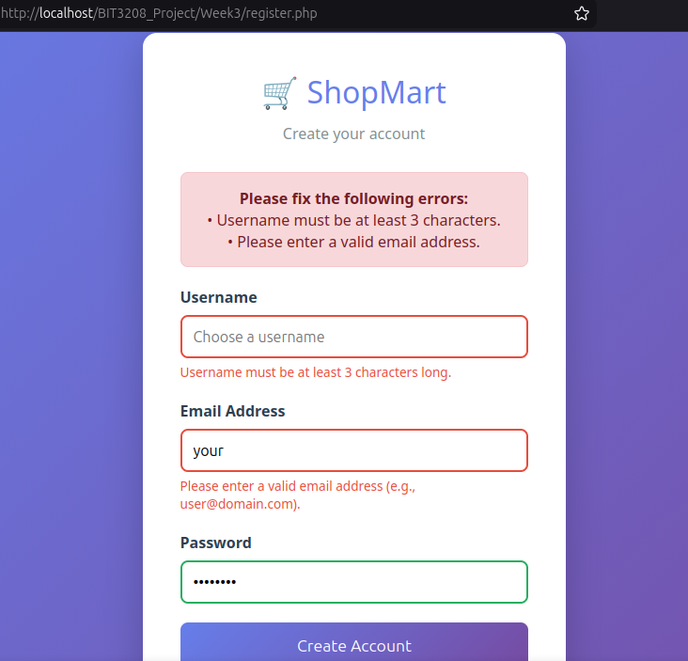

Fig 2: Password Strength Checker
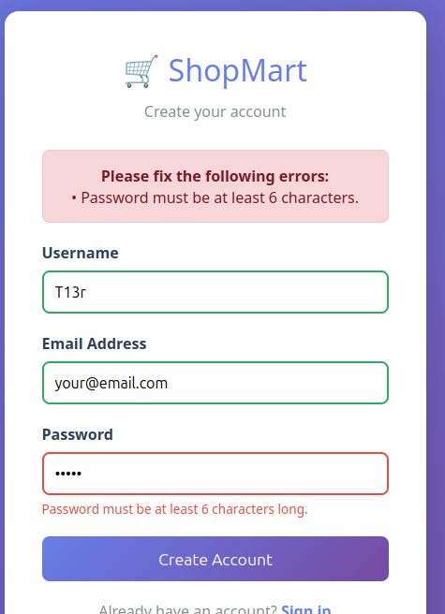

Fig 3: PHP Syntax Practice
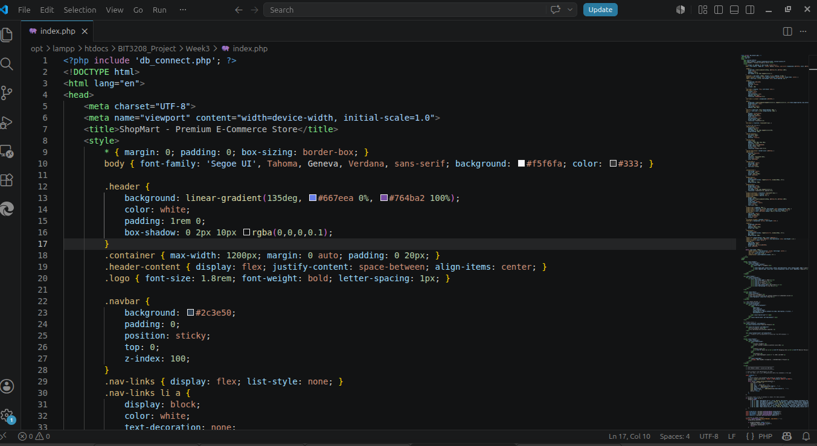

Fig 4: Database Connection Script
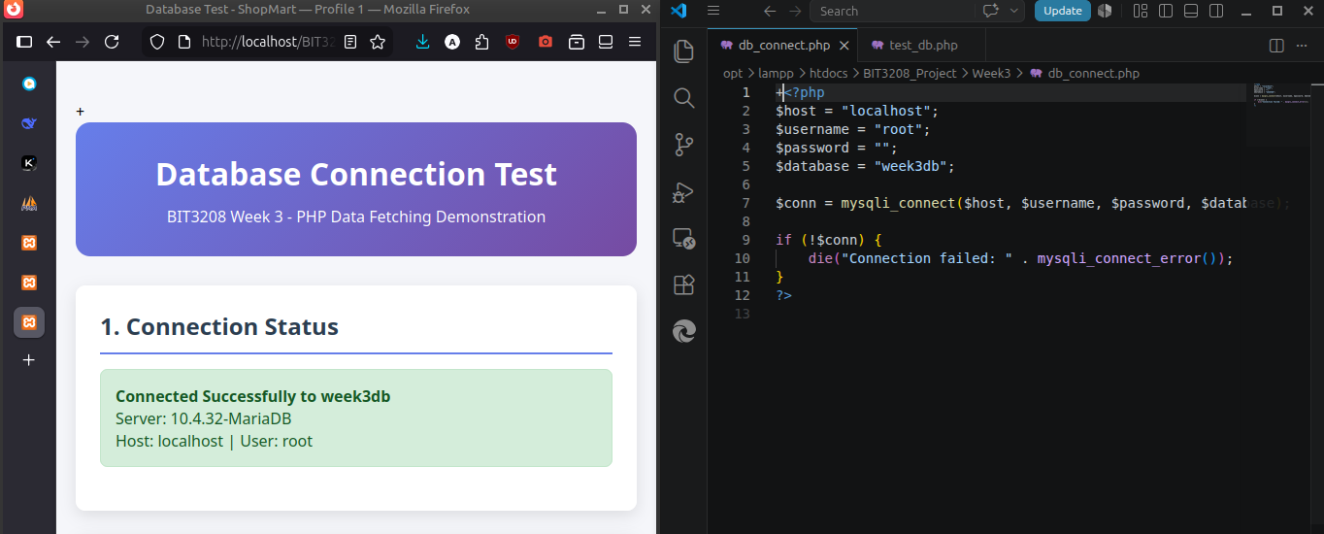

Fig 5: Dynamic User Input Handling
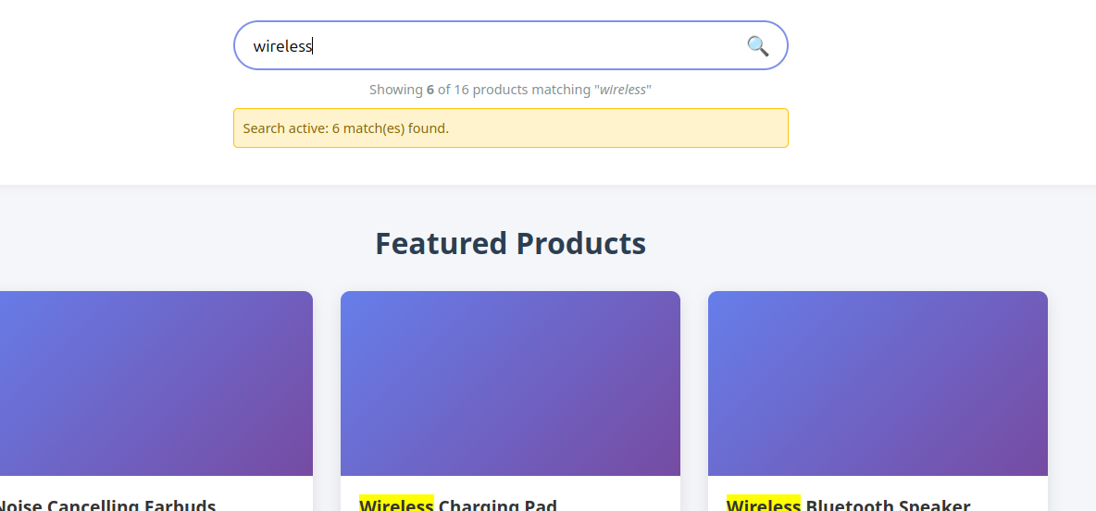

Student Reflection
The login validation prevents users from submitting empty forms from Fig 1. PHP was used to process form data while MySQL stored the records. JavaScript improved user interaction and allowed for dynamic user input handling. before data reaches the server.

Week 4: Server-Side Components.

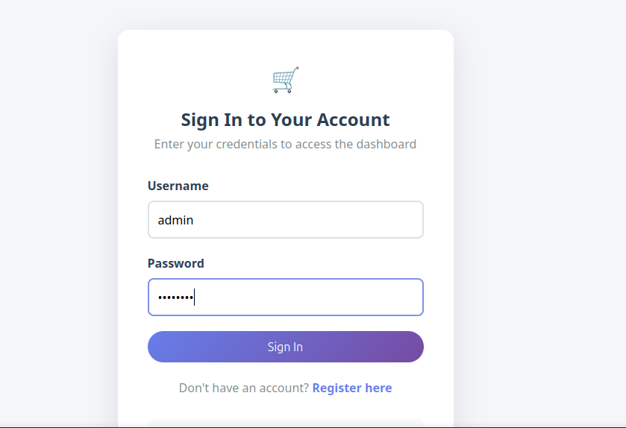
Fig 1. Login form

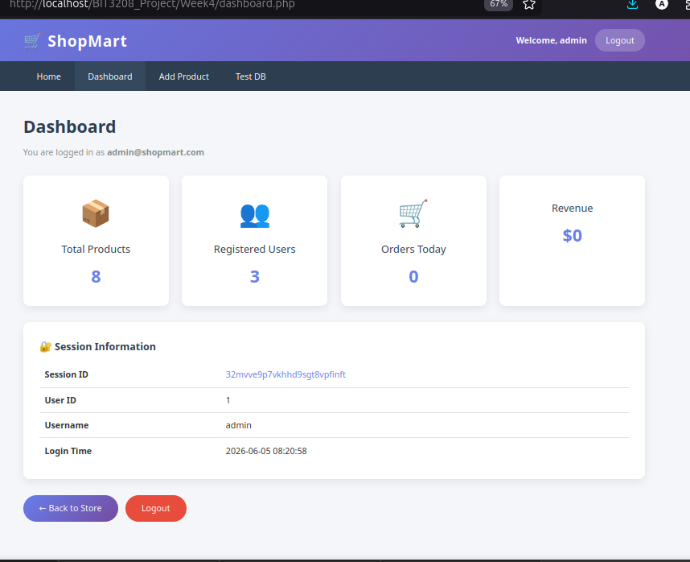
Fig 2. Admin dashboard

Fig 3. Succesful logout and redirect to login page
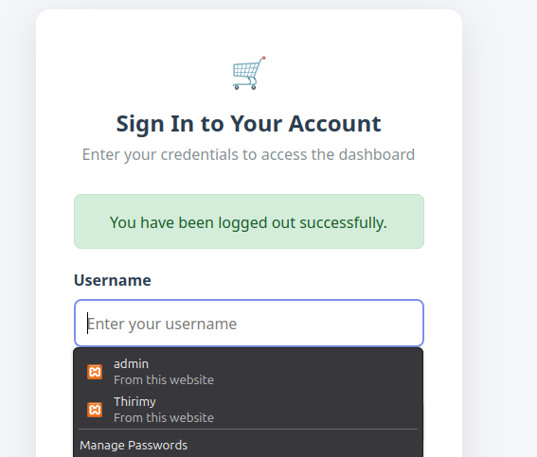

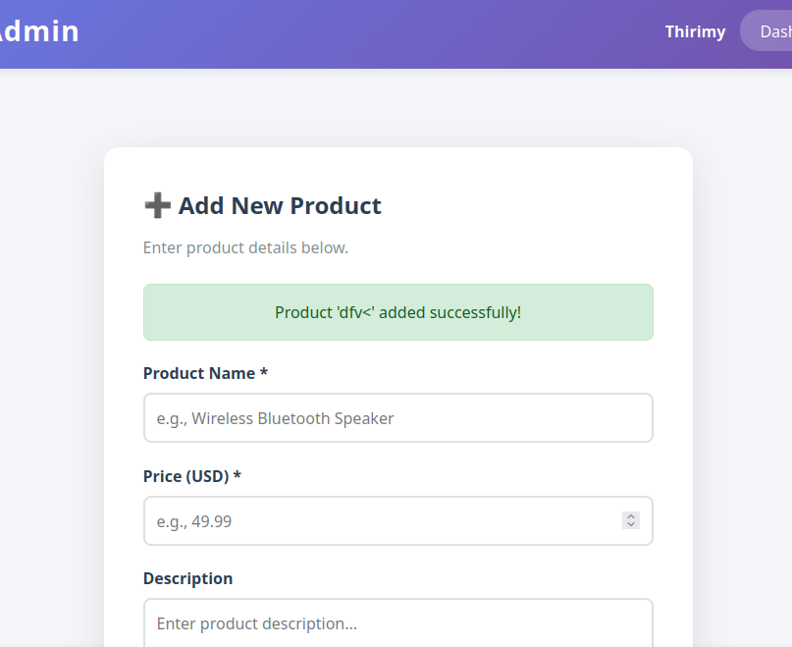
Fig 4. Add product protected

Add product now only works when logged in otherwise redirects to log in page

Week 5:Database Components & CRUD

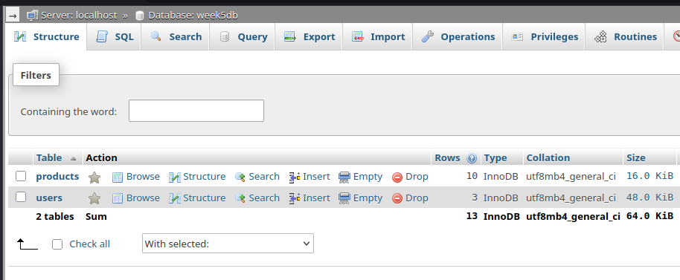
Fig 1. phpMyAdmin — week5db tables

Fig 2. Admin View. Full CRUD table with Edit/Delete buttons, admin logged in
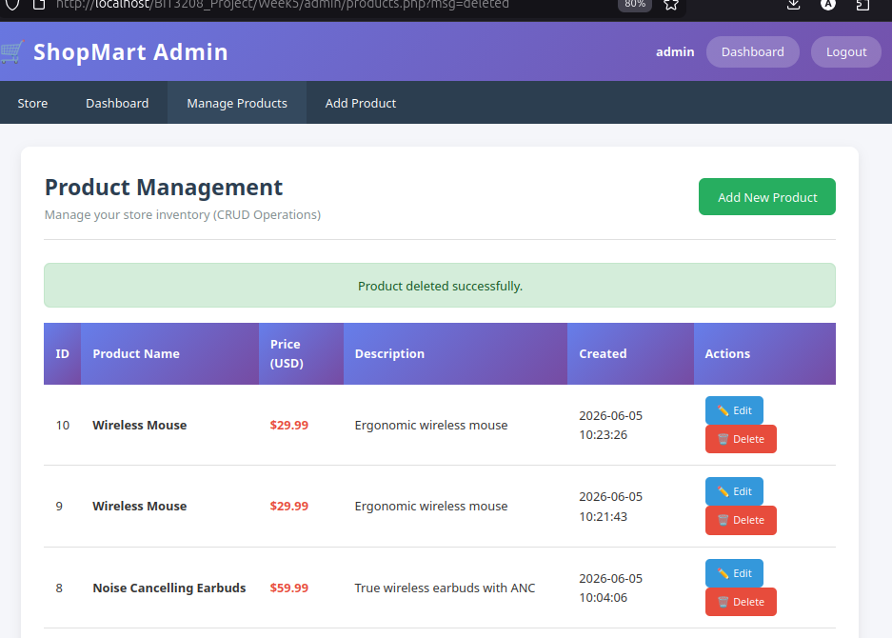

Fig 3. Access Denied - Logged in as john_doe
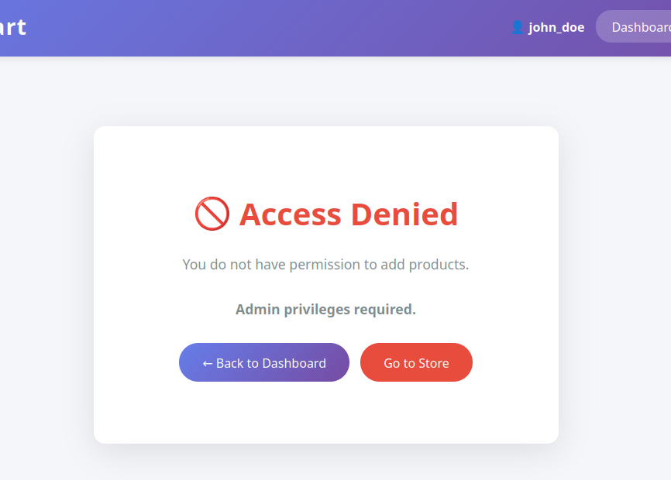

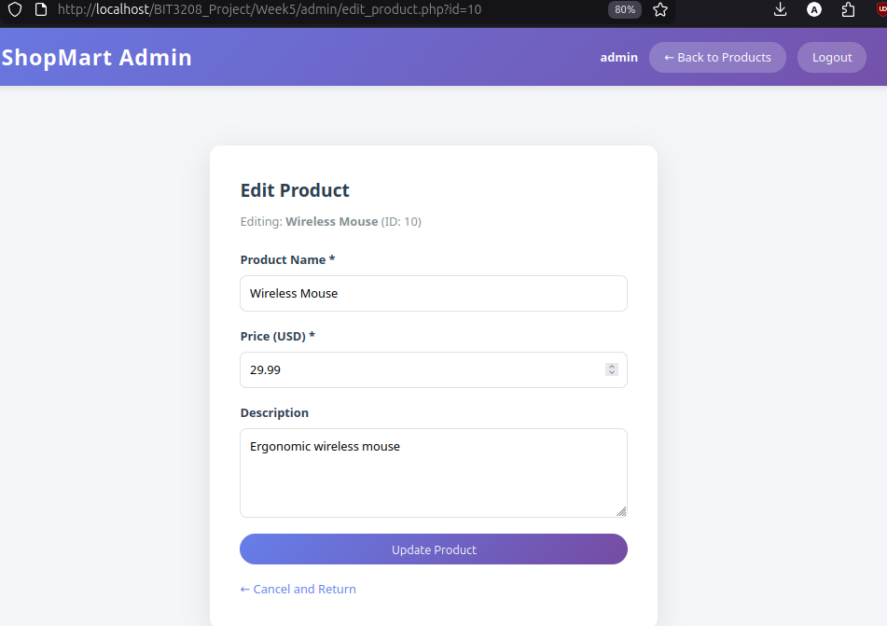
Fig 4. Editing a product and succesful update
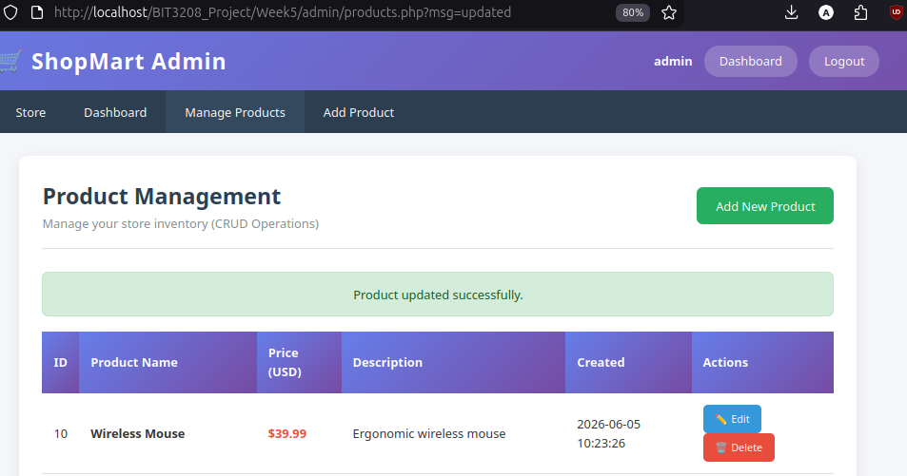

Fig 5. Delete product process
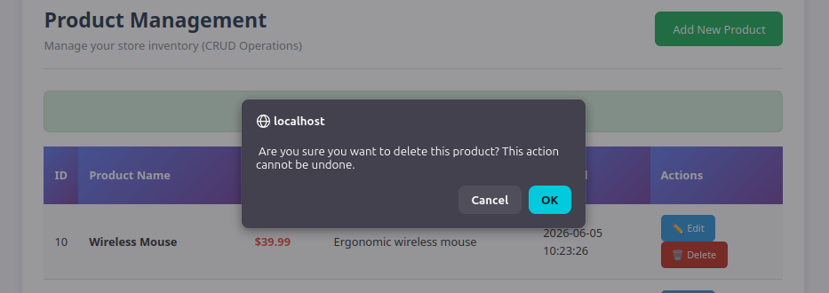
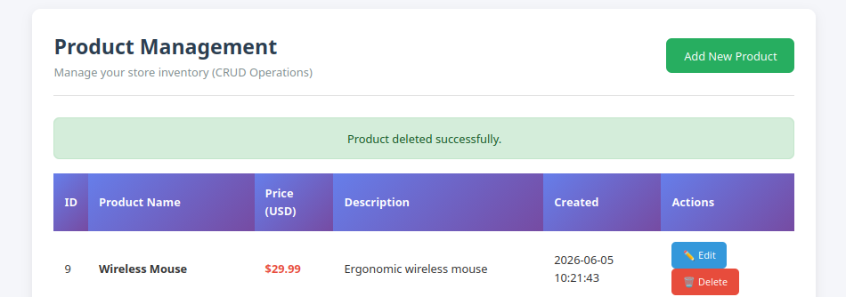

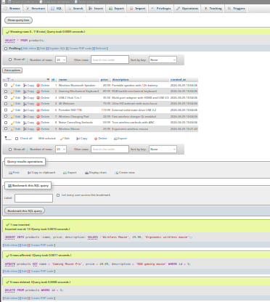
Fig 6. SQL Queries in phpMyAdmin

Fig 7. Session Info on Dashboard
